**SQL PROJECT**

**ScienceQtech Employee Performance Mapping**

**1.Create a database named employee then import** **data_science_team.csv** **proj_table.csv** **and** **emp_record_table.csv** **into the** **employee database from the given resources.**

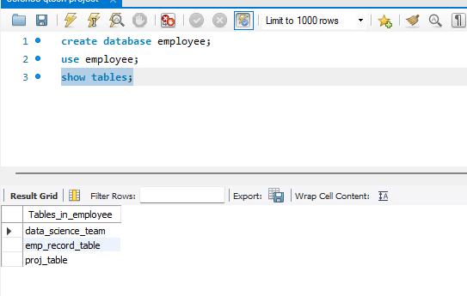

**2. Create an ER diagram for the given employee database.**

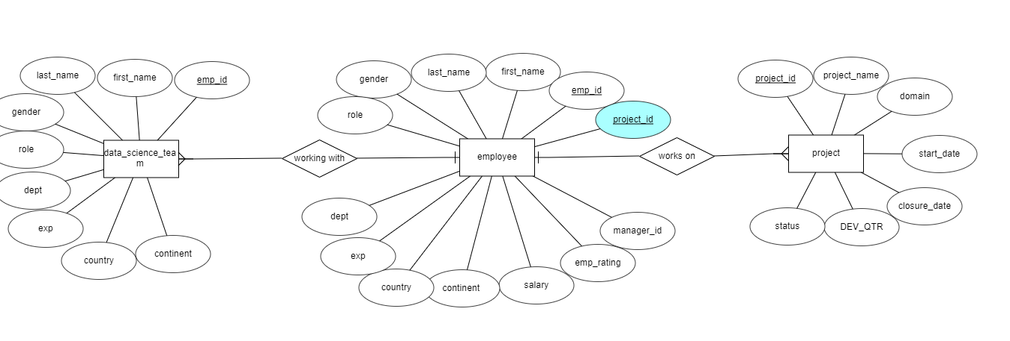

**3. Write a query to fetch EMP_ID, FIRST_NAME, LAST_NAME, GENDER, and DEPARTMENT from the employee record table, and make a list of employees and details of their department.**

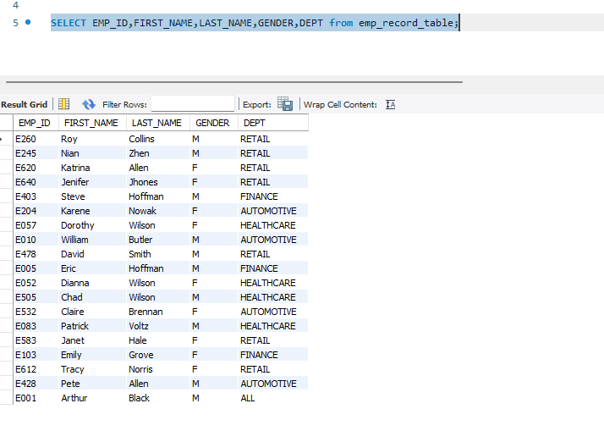

1. **Write a query to fetch EMP_ID, FIRST_NAME, LAST_NAME, GENDER, DEPARTMENT, and EMP_RATING if the EMP_RATING is:**

* **less than two**

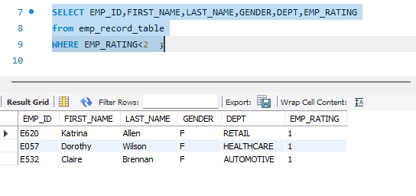

* **greater than four**

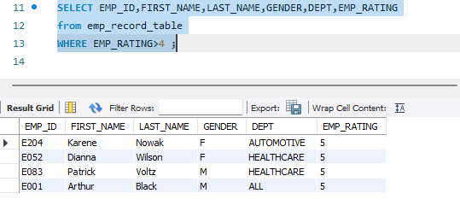

* **between two and four**

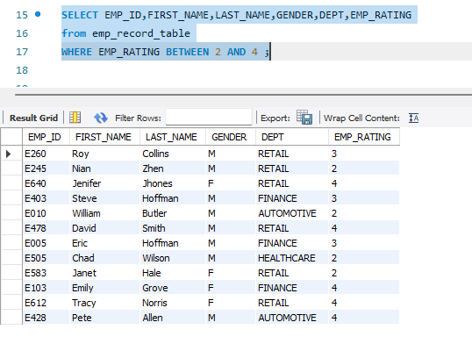

**5.Write a query to concatenate the FIRST_NAME and the LAST_NAME of employees in the Finance department from the employee table and then give the resultant column alias as NAME.**

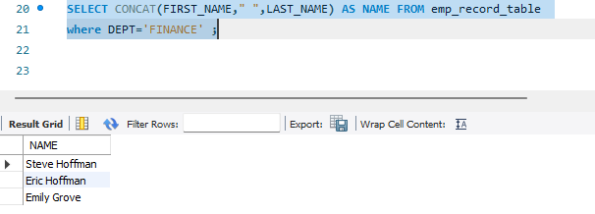

**6.Write a query to list only those employees who have someone reporting to them. Also, show the number of reporters (including the President).**

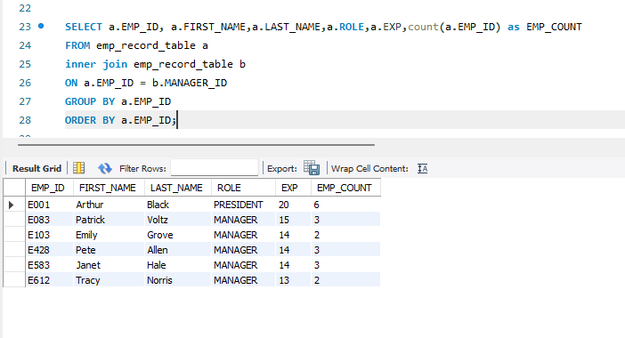

**7. Write a query to list down all the employees from the healthcare and finance departments using union. Take data from the employee record table.**

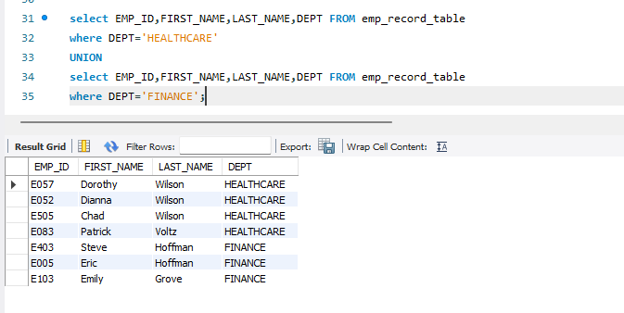

**8.Write a query to list down employee details such as EMP_ID, FIRST_NAME, LAST_NAME, ROLE, DEPARTMENT, and EMP_RATING grouped by dept. Also include the respective employee rating along with the max emp rating for the department.**

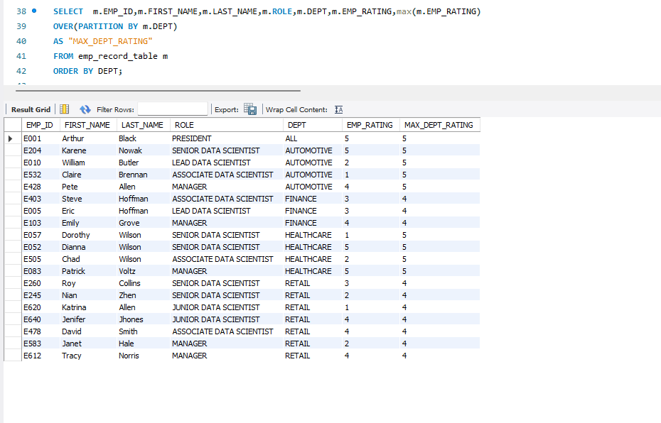

**9.Write a query to calculate the minimum and the maximum salary of the employees in each role. Take data from the employee record table.**

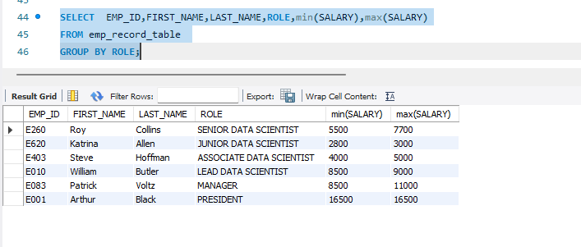

**10.Write a query to assign ranks to each employee based on their experience. Take data from the employee record table.**

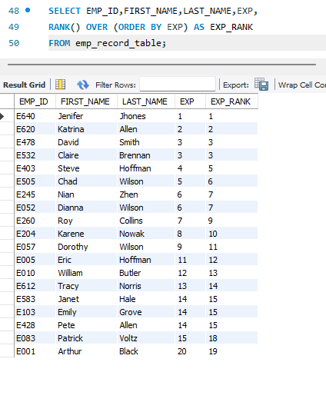

**11. Write a query to create a view that displays employees in various countries whose salary is more than six thousand. Take data from the employee record table.**

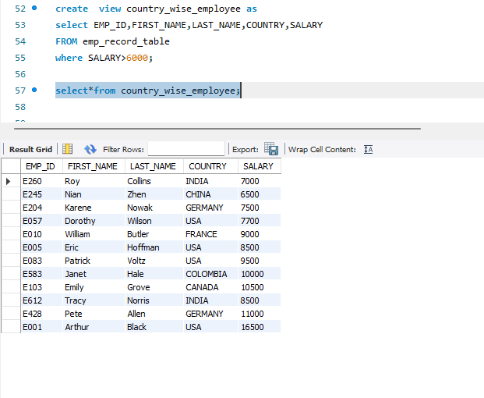

**12. Write a nested query to find employees with experience of more than ten years. Take data from the employee record table.**

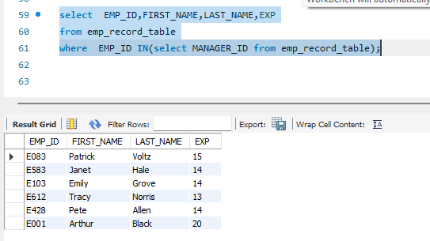

**13. Write a query to create a stored procedure to retrieve the details of the employees whose experience is more than three years. Take data from the employee record table.**

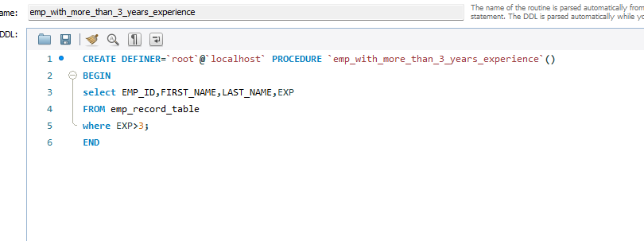

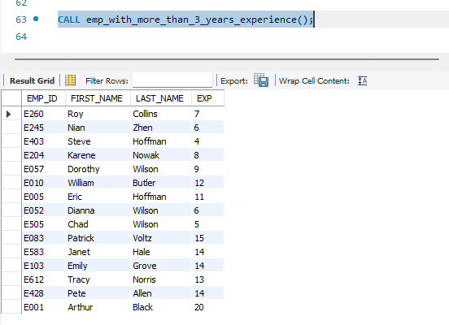

**14. Write a query using stored functions in the project table to check whether the job profile assigned to each employee in the data science team matches the organization’s set standard.**

**The standard being:**

**For an employee with experience less than or equal to 2 years assign 'JUNIOR DATA SCIENTIST',**

**For an employee with the experience of 2 to 5 years assign 'ASSOCIATE DATA SCIENTIST',**

**For an employee with the experience of 5 to 10 years assign 'SENIOR DATA SCIENTIST',**

**For an employee with the experience of 10 to 12 years assign 'LEAD DATA SCIENTIST',**

**For an employee with the experience of 12 to 16 years assign 'MANAGER'.**

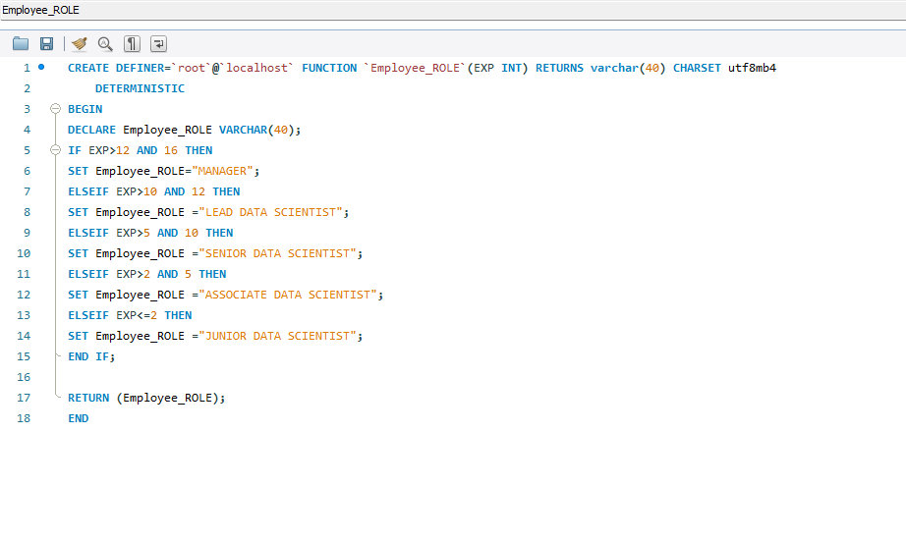

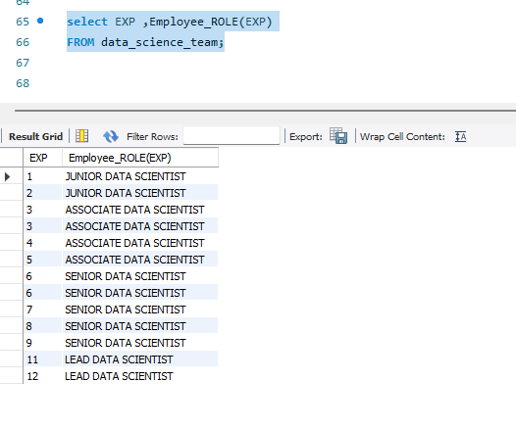

**15.Create an index to improve the cost and performance of the query to find the employee whose FIRST_NAME is ‘Eric’ in the employee table after checking the execution plan**

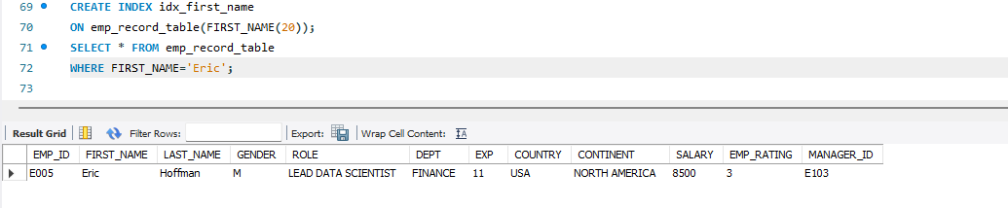

**16. Write a query to calculate the bonus for all the employees, based on their ratings and salaries (Use the formula: 5% of salary * employee rating).**

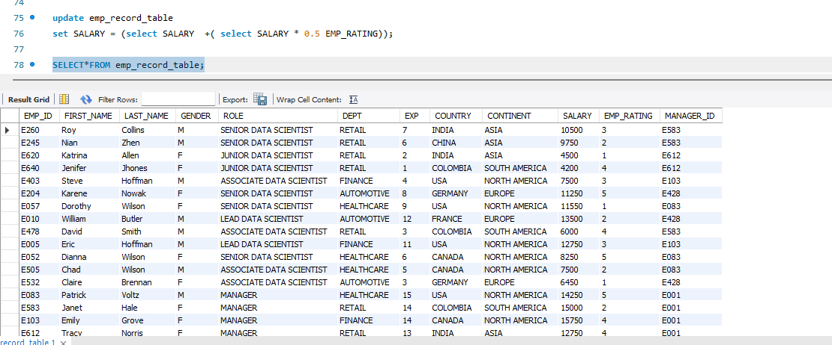

**17.Write a query to calculate the average salary distribution based on the continent and country. Take data from the employee record table.**

